**Paket B**

**LISTENING SECTION**

In this section of the test, you will have the chance to show how well you understand spoken English. There are four parts to this section with special directions for each part.

Part I (Questions 1 to 4)

**Directions:**

In this part of the test, you will hear some dialogs and questions spoken in English. The dialogs and questions will be spoken two times. They will not be printed in your text book, so you must listen carefully to understand what the speakers say.

After you listen to a dialog and the question about it, read the five possible answers and decide which one would be the best answer to the question you have heard. Now listen to a sample question.

You will hear:

Waitress : Good evening, sir.

Mr. William : Good evening. I want a table for two.

Narrator : You will also hear

What would the waitress say?

You will read in your test book:

1. Let’s go in.
2. This is the bill, sir.
3. Oh, yes. It’s over there.
4. The entrance is this way.
5. Yes, sir. Please come with me.

**Sample answer**

**E**

**D**

**C**

**B**

**A**

The best answer to the question is “Yes, sir. Please come with me.”

Therefore, you should choose answer (E)

1. A. Pride.

B. Surprise.

1. Compliment.
2. Impossibility.
3. Dissatisfaction.
4. A. He didn’t have an alarm clock.
5. He overslept and missed the bus.
6. He couldn’t sleep well.
7. He slept late last night.
8. He set the alarm clock.
9. A. He wants to praise the woman’s son.

B. He wants to apply for a job in Singapore

1. He wants to confirm the story he just heard.
2. He wants the woman to give the explanantion.
3. He wants to grab success just like the woman’s son.
4. A. He will make sure that the woman is all right.
5. He wants her to do the experiment again.
6. He doesn’t know what his partner did.
7. He will check to see what is wrong.
8. He will give her full marks for it.

Part II (Questions 5 to 7)

**Directions:**

In this part of the test, you will hear some incomplete dialogs in English, followed by five responses, also spoken in English. The dialogs and the responses will be spoken twice. They will not be printed in your test book, so you must listen carefully to understand what the speakers are saying. You have to choose the best response to each question.

**Now listen to a sample question:**

Man : Hello, Kiki. How have you been?

Woman : Oh, hi Bill. Not bad, thank you. How about you?

Man : ....

Narrator : **What will the man most likely reply?**

1. I’m glad. D. Take it easy.
2. I hope so. E. Yes, I do too.
3. Pretty Good.

**Sample answer**

**E**

**C**

**D**

**B**

**A**

The best answer to the question “How about you?” is choice C.

Therefore, you should choose answer C.

1. Mark your answer on your answer sheet.
2. Mark your answer on your answer sheet.
3. Mark your answer on your answer sheet.

Part III (Questions 8 to 11***)***

**Directions:**

In this part of the test, you will hear some monologs spoken in English. The monologs will be spoken twice. They will not be printed in your test book, so you must listen carefully to understand what the speakers say. After you listen to the monolog, look at the five pictures provided in your test book, and decide which one would be the most suitable with the monolog you have heard.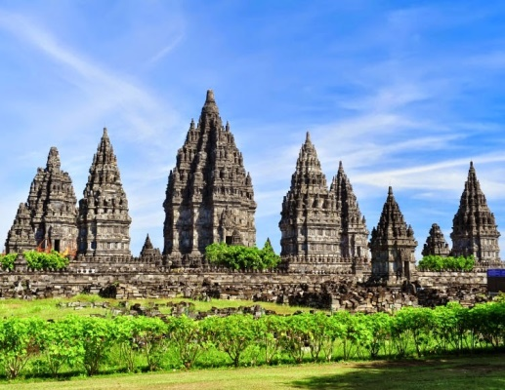

8.

A B C

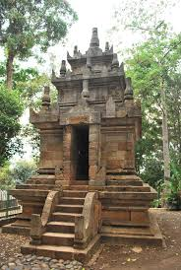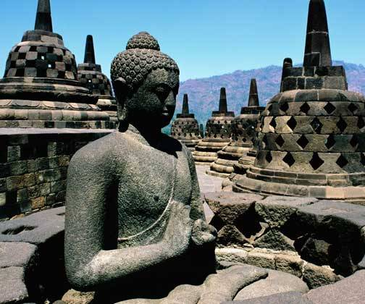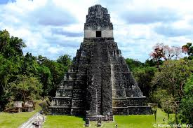

D E

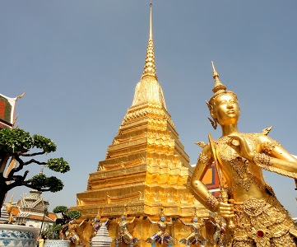

9. A B C



D E



10. A B C D E

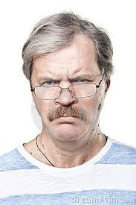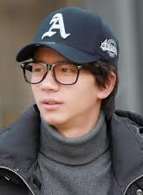

11. A B C

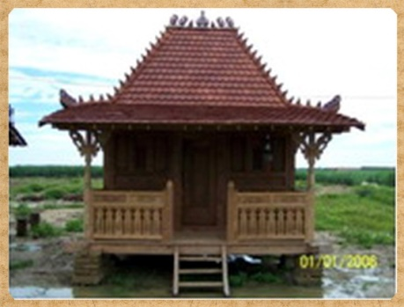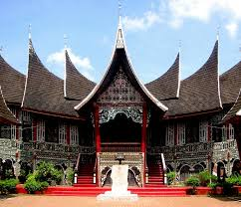

D E

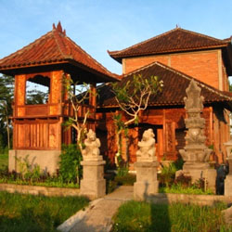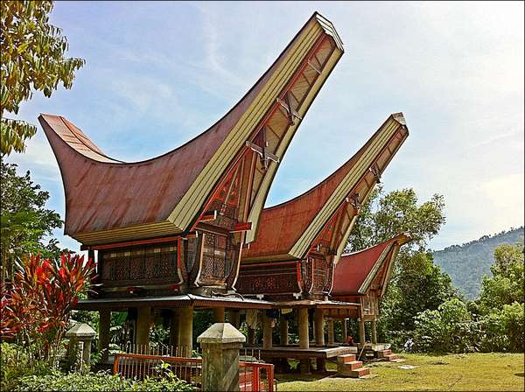

Part IV (Questions 12 to 15)

**Directions:**

In this part of the test, you will hear several monologs. Each monolog will be spoken twice. They will not be printed in your test, so you must listen carefully to understand what the speakers are saying. After you hear the monolog and the question about it, read the five possible answers and decide which one would be the best answer to the question you have heard.

1. A. To engross the listeners.
2. To describe the moon and the sun.
3. To tell a certain event long time ago.
4. To persuade the listeners to hate the sun.
5. To explain why the sun and the moon appear differently.
6. A. The moon left the sun.
7. The sun left the moon.
8. The sun loved the moon very much.
9. The sun light hurt the moon’s eyes very much.
10. The sun and the moon lived happily together in the sky.
11. A. Lukito.
12. The seismic activity.
13. West Sumatra Province.
14. Gunung Sitoli in Nias Island.
15. The Meteorology and Geophysics Agency.
16. A. In Gunung Sitoli, Nias Island.
17. Under the Indian Ocean
18. Under Gunung Sitoli.
19. In North Sumatra.
20. In West Sumatra.

**This is the end of the listening section**

**This text is for questions 16 - 18**

**Pros and Cons of Savings Account**

The traditional way to save money for families and individuals was to put your money into savings account, and then allow it to grow interest from there. Times have changed, and now some people think that the savings accounts that we once used and loved aren't as valuable to us anymore.

Savings accounts are fundamental money management tools that can help you meet your long- and short-term financial needs. Knowing the pros and cons of savings accounts can help you figure out how to use them effectively.

The most obvious advantage of a saving account is that deposited funds accrue interest over time. Money under your mattress or in a home safe misses out on valuable earning potential. The rate you earn depends on where you deposit your money. Online banks tend to offer more competitive interest rates because their overhead expenses are lower than those of brick-and-mortar banks. Another important advantage is security. When you place your money in a bank, the government insures it up to the maximum amount allowed by law. So, compared to a number of other options, your money is safe in a savings account.

Compared with certificates of deposit (CDs) and other higher-interest bank products, savings accounts generally pay a lower rate of interest. In other words, the interest that you get on your money saved is very low. If you're willing to keep your money deposited for a specific time period—anywhere from a few months to a few years, depending on what you choose—you generally can earn more interest with a CD than with a savings account. Some banks charge fees on their savings accounts. Be sure to compare the terms of different banks and look for those that offer savings accounts with no monthly maintenance fees.

Saving money for the future is an essential part of making responsible financial decisions. It’s worth your time to weigh the pros and cons before deciding on a savings account that works for you.10

1. What is the greatest benefit of saving money in a bank according to the passage?
2. Saving money in a bank is more secure.
3. Customer’s deposit will rise periodically.
4. There are some competitive interest rates.
5. Government guarantees customer’s deposit.
6. Customers are able to manage their own money
7. How many kinds of way to save money according to the passage?
8. 5
9. 4
10. 3
11. 2
12. 1
13. What is the main idea of paragraph 3?
14. The periodic rise of customer’s deposit.
15. The secure way to save money in a bank.
16. The beneficial arguments of saving money in a bank.
17. The drawbacks of saving account in state or private bank.
18. The government’s official guarantee on customer’s deposit.

***This text is for questions 19 -21***

On a chilly winter night, my best friend, Sarel Steinauer and I were driving on a freeway that was covered in a thin plane of ice. To make matters worse I was drunk. Sarel had warned me not to drink too much but as usual I ignored his warning if I ever heard it over the racket of the nightclub that we had just been attending. As I was driving, the beer started to take effect; somehow I resisted the dizziness effects until we were about halfway home.

As I was halfway in a sharp right turn just about to exit the freeway, I saw a flash of light streak past my left eye. Seconds later, there was a deafening explosion. The darkness seemed to recede as I slowly regained consciousness. Suddenly there was a roaring fire and I immediately unbuckled my seat belt, wanting to get out as soon as possible.

Somehow I got out the car and it was then that it hit me with a thrill of horror, Sarel was gone. In fact it took me nearly ten minutes to find him. He had been catapulted nearly fifteen feet from where the car was. As I stood by his side, I realized that his injuries were far worse than my own.

"Nicholas, tell my parents that I love them and my sister too. And one last thing, if you ever get the chance tell her everything that I told you on that day," Sarel said with his last breath.   
"I will" I promised him, holding back tears. "Goodbye Nicholas" and with those last words, he died.

His parents and not only them but a great deal of his classmates cried as his coffin was lowered into the ground to be entombed forever beneath the earth. As the funeral came to a close his, I left unable to take anymore. Although he is dead, Sarel's memory will forever live on in our hearts.5 <http://www.write4fun.net/view-entry/113719>

1. Why had Sarel reminded Nicholas strictly for many times?
2. Sarel had a worse experience on driving with no consciousness.
3. Sarel warned him not to drink too much because it shortens his life.
4. Nicholas needn’t drive the car fast because there were so many times.
5. Being drunk caused by too much alcohol can endanger their life in driving the car.
6. Sarel got frightened while he saw Nicholas fighting with some men in the nightclub.
7. What is the main idea of paragraph four?
8. Nicolas’ apology for what had happened.
9. The reason why the accident happened.
10. The time when Sarel’s classmate cried.
11. Sarel Steinauer’s love to his parents.
12. Sarel Steinauer’s last messages.
13. It is implied that ….
14. Nicholas’ friend was drunk driving the car
15. Nicholas cautiously drove the car in the free way
16. Nicolas’ left eye was troubled by a flash of light
17. Nicolas and Sarel talked and joked too much in the car
18. the car unfortunately hit another car in the sharp right turn

**This text is for questions 22 - 24**

JK. Rowling was born in Chipping Sodury, July 31st 1965. Her childhood was generally happy, although she does remember getting teased because of her name, “Rowling” – She recalls often getting called “Rowling pin” by her less than ingenious school friends. She studied at St Michael’s Primary School in Gloucestershire, before moving to Chepstow, South Wales at the age of nine.

From an early age, JK. Rowling had an ambition to be a writer. She often tried her hand at writing, although little came from her early efforts. Aged six she wrote a book about a rabbit with measles. After her mother praised her effort, Rowling replied ‘well get it published then.’ She admits it was a ‘Bit of an odd thing for a child of six to think. I don’t know where it came from…”

In 1991, she left England to get a job as an English teacher in Portugal. It was here that she met her first husband, Jorge Arantes – and had a child Jessica. However, after a couple of years, the couple split after a fierce argument; where by all accounts JK. Rowling was thrown out of the house.

On the 21st December 2006, she finished her final book of the Harry Potter Series – “*Harry Potter and the Deathly Hallows*“. The book was released in July 2007, becoming one of the fastest selling books of all time. Rowling has said the book is her favourite, and it makes her both happy and sad. She has said she will continue writing but there is little chance of continuing the Harry Potter Series. She however, may release a dictionary of things related to Hogwarts and Harry Potter that were never published in other books.

Rowling currently lives in Scotland, on the banks of the river Tay, with her 2nd husband Neil Murray; and has 3 children, two with husband Neil.3

1. The text tells us about....
2. the achievement of J.K Rowling
3. the description of J.K Rowling
4. the childhood of J.K Rowling
5. the ambition of J.K Rowling
6. the life of J.K Rowling
7. How did J.K Rowling divorce?
8. She split with her husband after two years with no a big deal problem.
9. She moved from England to Portugal because of being teacher .
10. She was forced to divorce because of her career demands.
11. She was the only one person who earned for their living
12. She had different perspective with her husband.
13. “The book was **released** in July 2007.”

The underlined word means....

1. edited
2. written
3. launched
4. promoted
5. announced

**This text is for questions 25 and 26**

ANNOUNCEMENT

Due to the Education Ministry decree mentioned that all students especially in government high schools are obliged to take final Exam or Ujian Nasional based on computer or CBT, we are expectedly eager to invite all English teachers to come and join at CBT Training held by our MGMP on Monday, February 22, 2016, 08.00 PM at SMA Negeri 56 West Jakarta.

This announcement is legally made based on the instruction of the local authority and the official invitation will be distributed at the time. Please also bring your laptop and cable roll. To make it easier and more efficient, each participant is expected to prepare a softcopy of complete paper based test which is later going to be converted into CBT. A flask disc and modem will be necessary also.

Hopefully, this program will give any important contributions to our beloved students in facing the exam. Thanks for your attention and we are looking forward to seeing all of you at the training.1

1. What is the text about?
2. The instruction of using CBT for *Ujian Nasional*
3. The legal notification for using CBT in Ujian Nasional.
4. The CBT training invitation for teachers in West Jakarta.
5. The importance of using CBT for Ujian Nasional to students.
6. The announcement of new regulation on CBT for *Ujian Nasional*.
7. A teacher should bring … beside a laptop, cable roll, a flask disc and modem in the training.
8. the CBT training invitation
9. the legal letter of invitation
10. the softcopy of the test
11. an identity card
12. CBT software

**This text is for questions 27 - 30**

An old man named Takahama lived in a little house behind the cemetery of the temple of Sozanji. He was extremely amiable and generally liked by his neighbors, though most of them considered him to be a little mad. His madness, it would appear, entirely rested upon the fact that he had never married or evinced desire for intimate companionship with women.

One summer day he became very ill, so ill, in fact, that he sent for his sister-in-law and her son. They both came and did all they could to bring comfort during his last hours. While they watched, Takahama fell asleep; but he had no sooner done so than a large white butterfly flew into the room and rested on the old man's pillow. The young man tried to drive it away with a fan; but it came back three times, as if loath to leave the sufferer.

At last Takahama's nephew chased it out into the garden, through the gate, and into the cemetery beyond, where it lingered over a woman's tomb, and then mysteriously disappeared. On examining the tomb the young man found the name "Akiko" written upon it, together with a description narrating how Akiko died when she was eighteen. Though the tomb was covered with moss and must have been erected fifty years previously, the boy saw that it was surrounded with flowers, and that the little water tank had been recently filled.

When the young man returned to the house he found that Takahama had passed away, and he returned to his mother and told her what he had seen in the cemetery. "Akiko?" murmured his mother. "When your uncle was young he was betrothed to Akiko. When Akiko left this world, your uncle resolved never to marry, and to live ever near her grave. For all these years he has remained faithful to his vow, and kept in his heart all the sweet memories of his one and only love. Every day he went to her grave and prayed for her happiness, swept the tomb and set flowers there. When Takahama was dying, and he could no longer perform his loving task, Akiko came for him. That white butterfly was her sweet and loving soul."6

[*http://www.pitt.edu/~dash/japanlove.html#snowbride*](http://www.pitt.edu/~dash/japanlove.html#snowbride)

1. From the last paragraph, the white butterfly represented ….
2. Takahama’s sister
3. Takahama’s fiancée
4. Takahama’s mother
5. Takahama’s nephew
6. Takahama’s sister in-law
7. Why did Takahama decide to be an unmarried man?

Because ….

1. Akiko betrayed Takahama’s sincere love
2. Takahama loved The late Akiko very much
3. Akiko never wanted to be betrothed with Takahama
4. Akiko promised to accompany him as near as possible
5. Takahama’s love was end with Akiko because of their parents
6. What moral lesson can you get from the text?
7. One should respect the dead.
8. One’s good deed will result in good thing.
9. One should be faithful to one’s spouse indeed.
10. Never underestimate a vow which one has made.
11. We shouldn’t chase away a butterfly which visits your house.

This text is for questions 30 and 31

**To**: Kim Gun <kgun@kc-e.com>

**Cc**: All Staff

**From**: Jack Long <jlong@kc-e.com>

**Subject**: Welcome to our Team!

Dear Kim,

Welcome to our Team!

It is a pleasure to welcome you to the staff of KC Electronics. We are excited to have you join our team, and we hope that you will enjoy working with our company.

On the first Monday of each month we hold a special staff lunch to welcome any new employees. Please be sure to come next week to meet all of our senior staff and any other new staff members who have joined us this month. Alice Peters will email you with further details.

If you have any questions during your training period, please do not hesitate to contact me. You can reach me at my email address or on my office line at 340-2222.

Warm regards,

Jack

Jack Long

Sales Manager2

1. What is Long’s intention in writing the letter? Communicative purpose
   * + - 1. To ask Peters to write a welcome letter for Kim at Jack’s company.
         2. To register Kim Gun to be a new employee in Jack’s company.
         3. To give welcome information for Kim as a new employee.
         4. To join an informal meeting with Jack in a certain place.
         5. To invite all KC electronics employee to have lunch.
2. From the text, we know that …. (Detailed info)

Kim has ever worked as a staff in the company

A monthly lunch tradition to accept any new employees is held by the company

The company holds a formal meeting to evaluate the team work on Mondays

Jack Long points out Alice Peters as a senior staff in the KC Electronic

Alice was used to handle the administrative affairs in that company.

**This text is for questions 32 - 34(P**

Here's how you can save money and do your bit for the environment.

Saving electricity:

* Buy energy efficient appliances - download the [Energy Rating App](http://www.energyrating.gov.au/for-consumers/energy-ratings-mobile-app/) to see the running costs.
* Switch off your heater, air-conditioner and lights in rooms you're not using.
* Keep your curtains or blinds drawn at night to keep the heat in.
* Use a door snake under the door.
* Turn off the heater and put on jumper.
* Turn off your electrical appliances at the power point.
* Turn off the TV and computer when no-one is using it.
* Use energy efficient light bulbs.
* Turn on the washing machine and the dishwasher only when they are full.4

1. What does the text tell you about? General picture
2. Directions to turn on the washing machine only when it’s full.
3. Directions to turn on TV when no one is using it.
4. How to save money on electricity.
5. How to use energy appliances.
6. How to use energy eficiently.
7. We should keep the curtains or blinds drawn at night in order to …. Specific info
8. keep the temperature warm anytime
9. avoid the light enter to the room
10. give a convenient condition
11. prevent the light going out
12. save the energy efficiently
13. “Turn on the TV and computer when no one is using it.” reference

What does the word ‘it’ refer to?

1. TV.
2. Heater
3. Light bulb.
4. Computer.
5. Washing machine.

**This text is for questions 35 - 38**

**rocedure**

Rabbits are small, herbivorous [mammals](http://www.wisegeek.org/what-are-mammals.htm) with acute sight and hearing. They hide from predators using these characteristics, along with their speed, and often retreat to underground burrows. Together with hares, they make up family Leporidae, and with both hares and pikas, order Lagomorpha (lagomorphs). They are one of the only species of animal simultaneously considered pets, pests, and livestock animals by people in the same culture.

Rabbits are small, furry, mammals with long ears, short fluffy tails, and strong, large hind legs. They have 2 pairs of sharp incisors (front teeth), one pair on top and one pair on the bottom. They also have 2 peg teeth behind the top incisors. Their teeth are specifically adapted for gnawing and grow continuously throughout their lives.

Using their powerful hind legs, rabbits move by hopping. They have 4 toes on their hind feet that are long and webbed to keep them from spreading apart as they jump. Their front paws have 5 toes each. Some species of rabbit can reach speeds of 35 to 45 miles per hour (55 to 70 kilometers per hour). Young rabbits seem to walk instead of hop.

Rabbits vary in color and size, ranging in weight from 2 to 16 pounds (1 to 7 kilograms), depending on breed. Pet rabbits that have been well taken care of and spayed or neutered early in life have a life expectancy of 8 to 12 years.

Although they mostly live in temperate areas located in the middle latitudes of the Americas, Europe, and Africa, rabbits can live in a variety of environments. They are also found in India, Sumatra, and Japan. These animals can be white, brown, gray, or brownish-yellow in color, with the black Amami and two striped black species from Asia being exceptions.7

1. What does the text mainly tell about? General picture
2. The characteristics of rabbits.
3. The rabbits’ medium life-expectancy.
4. The rabbits’ spread in temperate areas.
5. A small animal with light weight called rabbit
6. The indigenous rabbits from the family of Leporidae
7. What information can you get about the rabbit from the text about? Detailed info
8. Younger rabbits always like hopping to anywhere.
9. Rabbits’ teeth stop growing when they are mature.
10. Rabbits only have some pairs of teeth to swallow the food.
11. Rabbits are the only livestock animal in the world.
12. Rabbits are consumed in some part of the world.
13. It can be implied that rabbits …. Implied
14. are tame animals
15. eat green leaves for daily food
16. are only found in middle latitudes
17. always get the meat from the man
18. mostly get the food from smaller animals like fish
19. Rabbits are considered as livestock animals because …. implied
20. they can reach speed of 35 to 45 miles per hour
21. they can live in any parts of the world
22. they can eat meat and vegetables
23. they can be eaten by people
24. they have various colors

**This text is for questions 39 - 41(**

Coffee is a very interesting product. Being one of the most popular drinks in the world, it is a subject of many studies where researchers try to find out how it affects people’s health.

If you wake up in the morning and feel groggy, you might reach for coffee to help pep you up. Many people who drink coffee every morning think of the drink as a godsend. But while drinking coffee can help you wake up, it might cause problems to you in other ways. It can cause changes in your sleep patterns, raise your blood pressure, stain your teeth and even make it more difficult to absorb certain vitamins and minerals.

I used to drink coffee a lot, and I tried to find an answer to that question for myself, I did my own research and noted the most significant potential serious health risks of coffee drinking. Here is the conclusion to what I have found that The Medscape News report mentions that besides the potential increase in blood pressure, coffee can incite or worsen anxiety, insomnia, tremor and potentially elevate glaucoma risk.

Furthermore, soft drinks, tea and [chocolate](http://authoritynutrition.com/7-health-benefits-dark-chocolate/) all contain caffeine, but coffee is the biggest. Caffeine is known as a [stimulant](http://authoritynutrition.com/stimulants-in-tea/). In the brain, it blocks the function of an inhibitory neurotransmitter (brain hormone) called Adenosine. By blocking [adenosine](http://en.wikipedia.org/wiki/Adenosine), caffeine actually increases activity in the brain and the release of other neurotransmitters like *norepinephrine* and *dopamine*. This reduces tiredness and makes us feel more alert. Finally, it can cause problems in some people and disrupt sleep.

Although I enjoy a cup of coffee now and again, I don’t consider it as food required for my health and wellbeing. But there is absolutely nothing nutritional about coffee indeed.8

39. Why do people have some sleeping disruptions after drinking coffee? Detailed info

1. Coffee has a certain substance to make people alert.
2. It contains a dangerous substance which affects the work of the heart.
3. Coffee contains *norepinephrine* and *dopamine* that make people sleepy.
4. Scientists have proven that coffee has neurotransmitters cause us healthy.
5. It causes sleeping disorder because of the existence of doping substance.
6. What does the fourth paragraph tell you about? Main idea
7. Drinking coffee anytime is beneficial for people.
8. The healthy benefits caused by drinking coffee.
9. The well-contributed substance in coffee
10. The additional effect of drinking coffee.
11. Some advantages of drinking coffee.
12. “Besides the potential increase in the blood pressure, coffee….” (Paragraph 3).

The word ‘**increase**’ is closest in meaning to …

1. decrease
2. equality
3. develoment
4. stimulation
5. enhancement

**This text is for questions 42-45 (**

**Jakarta.** Indonesian police have arrested a total of 11 people in connection with Thursday’s terrorist attack in downtown Jakarta, a source said on Saturday.

Raids over the past three days by Densus 88, the National Police’s counterterrorism squad, have netted 11 individuals with “direct or indirect links” to the attack that killed two people and left five perpetrators dead.

A source at the National Police told the Jakarta Globe that all those arrested in the wake of the attack had one thing in common: “They were all linked in some way to Bahrun Naim” – the Indonesian jihad based in Syria with the Sunni militant group Islamic State, who police allege masterminded the attack.

Gen. Badrodin Haiti, the National Police chief, previously said the five perpetrators killed on Thursday were “only the field operatives,” and that they must have had an extensive network of financial, logistical and material support.

“That’s why we’re going after their supporters. We’re going to keep chasing down everyone who was involved in the bombing. They might be in Jakarta, in the suburbs, or elsewhere,” he said.

Thursday’s attack comprised a series of blasts at the intersection of Jalan M.H. Thamrin and Jalan K.H. Wahid Hasyim in Central Jakarta. Police then engaged in a sporadic gun battle with the perpetrators before killing them.9

1. What is the text about? General picture
2. The national police counter attack to terrorism squad.
3. Thursday terrorist attack in downtown Jakarta.
4. Indonesian police failure to arrest the terrorist.
5. All the terrorist activities in the downtown.
6. The Indonesian jihad based in Syria.
7. According to the Gen Badrudin Haiti the national police chief, the terrorist were ….pecific info
8. only the operation fields
9. from the Sunni affiliation
10. all linked to Bahrudin Naim
11. the five perpetrators who had been trained skillfully
12. planning to chase the mastermind of the attack away
13. What does the paragraph 3 tell about? Main idea
14. The Indonesian jihad based in Syria
15. An important source about the terrorists’ syndicate.
16. The arrest of one of the mastermind, Bahrun Naim in the attack.
17. An intelligent source about the next terrorists’ plans in Jakarta.
18. The Syria with the Sunni militant group Islamic State terror activity in Jakarta.
19. How many terrorists died in the attack? Detailed info
20. 22.
21. 11.
22. 7.
23. 5.
24. 2.
25. Study the following sentences!

**RDS**

Everyone hates taking exams, but you can improve your study technique for them to avoid being caught unprepared. Here are the tips:

1. Last not but least, make studying a part of your habits. Too often, it's easy to view studying as something that only gets done at the last minute in a huge overnight cram session.
2. Then, pay attention in class. This seems like a no-brainer, but actually paying attention while you're in class will help you immensely once exam time comes.
3. Ask about the exam format. Ask your teacher what format the test will be in, how it will be graded.
4. First of all, review your syllabus. Figure out when all of your exams will be and how much of your grade they are worth (passing grade or *KKM)*.
5. After that, take good notes. This is easier said than done, but learning how to take good notes will help you immensely once it comes time to study.
6. Next, review your notes daily, right after class. This will help reinforce the information you just learned.11

The best arrangement is....

1. 4 – 2 – 6 – 5 – 1 – 3
2. 4 – 2 – 5 – 6 – 1 – 3
3. 4 – 2 – 6 – 5 – 3 – 1
4. 4 – 2 – 1 – 6 – 5 – 3
5. 4 – 2 – 3 – 6 – 5 – 3
6. Study the following sentences!

**RDS**

1. I went on many rides. 3
2. Recently, I went to Disneyland in Los Angeles. 1
3. It went very fast and I got a little wet. 5
4. My favourite ride was Splash Mountain. 4
5. I really had a wonderful time there. 2
6. I also enjoyed Tom Sawyer's Island. 6
7. We went there through a hanging bridge and walked through caves.12 7

The correct arrangement is....

* 1. 2 – 1 – 3 – 4 – 6 – 5 – 7
  2. 2 – 3 – 1 – 4 – 5 – 6 – 7
  3. 2 – 1 – 5 – 3 – 6 – 4 – 7
  4. 2 – 5 – 1 – 4 – 3 – 6 – 7
  5. 2 – 4 – 3 – 5 – 6 – 1 – 7

**The text is for questions 48 - 50**

***Complete the following text with the correct words!***

RDS

I am used to travelling by air but only on one occasion, I felt frightened. After taking off, we flew low over the city. It slowly went high to the sky.

It was on December, exactly 11, 2006, my wife and I were in a plane heading to *Polonia* airport from Jakarta. We sorrowfully had to go to my hometown, *Hutabayu Raja*, *Siantar* because my father had died a day before.

Suddenly, a crew … (48) the passengers that we were going to land in the *Polonia* airport in a few minutes. While listening to the announcement, I was looking outside through the window and saw how … (49) the sky was. It was raining heavily and lightning sparked here and there.

Unpredictable, I felt the plane went bumpy and trembled. The impact was low at the beginning, however it gradually became terrible. Everything shook terribly. People started to scream in fear. I hold my wife’s hands. I heard man behind me was praying while my wife tried to soothe me.

… (50), our plane landed safely at the airport under that extreme weather. I thanked God for saving my wife and me. Since then, I got a phobia on travelling by air.13

48. A. took

1. brough
2. checked
3. introduced
4. announced

49. A.soft

1. clear
2. dark
3. bright
4. smooth

50. A. Briskly

1. Broadly
2. Largely
3. Fortunately
4. Approximately